Lab – Steganography

NISGTC Security + Lab Series Lab 16: General Cryptography Concepts

-
http://www.itworld.com/article/2826840/crash-course-digital-steganography.html

Steganography (pronounced STEHG-uh-NAH-gruhf-ee, from Greek steganos, or "covered," and graphie, or "writing") is the hiding of a secret message within an ordinary message or another medium and the extraction of it at its destination. In this lab you will read and learn about Steganography and practice with some tools that allow you to hide messages/ files in images or audio files.

Part 1.
Check out some classical examples of steganography at this site: http://www.jjtc.com/stegdoc/sec202.html

To learn more about steganography, read the article “Steganography: Past, Present, Future” from the SANS Institute included in the Resources in CougarView. (attached in the dropbox as well)

- Find the hidden message in this text:

“Since everyone can read, encoding text in neutral sentences is doubtfully effective.”

Hidden Message: __ Secret inside__________________________________

- Come up with an example of steganography at work. Your example should use a different way than the example provided above. Be creative! Include your harmless looking text as well as how to extract the hidden message inside below:

Your example:
Solution:
Hiding information in plain text can be done in many different ways. The first-letter algorithm used in the above example is not very secure, as knowledge of the system will automatically give the secret. My example here is to write an html file as following (I attach this html file in Lab submission):

<!DOCTYPE html>
<html>

<head>
<title>my example</title>
<script>
document.createElement("article");
document.createElement("footer");
document.createElement("header");
document.createElement("section");
</script>
</head>

<body>

<header>
<h1>An Example of Hidden Message</h1>
<h2>CPSC 6126</h2>
</header>

<section>
<article>
<p>Here is some more related content for this topic. Around July, anyone may register for the event at the nearest library.
</p>
<p>Here is some more related content for this topic. Blah...
</p>
</article>
</section>

<footer>
<p>Last revised: 03/10/2019</p>
</footer>

</body>

</html>

How to extract the hidden message:
Extra spaces before certain words could indicate that those words should be taken apart from the entire message to reveal an embedded secret message. This is especially handy in html files since extra spaces show up only in the source file and not on the deployed webpage. This is how my example webpage looks like:

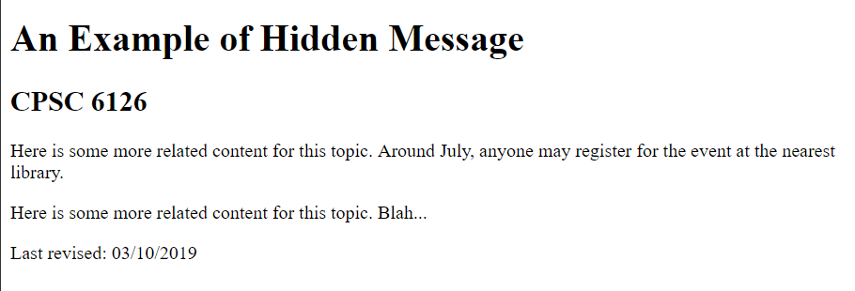

However, by examining the source code, we can find three words starting with one extra space, they are “around”, “July”, and “anyone”.

Hidden message:
The hidden message is embedded by taking the second letter out of these three words, it is “run”!

Part 2. Complete the attached lab in Netlab+.
To log in to Netlab go to http://netlab.columbusstate.edu.
Reserve a pod for individual use.

Take screenshots of your work at these steps and paste them in this document:

Step 16 on page 10
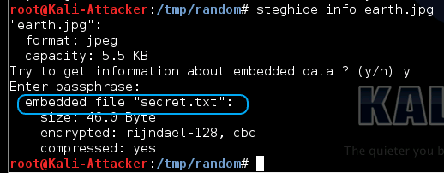

Step 7 on page 12
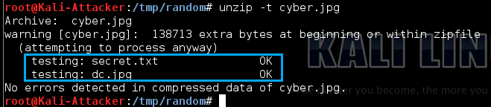

Step 16 on page 16
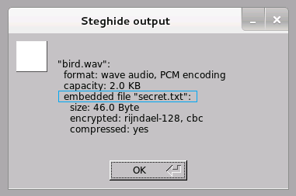

Note: You can use the Snipping Tool to take the screenshots on a Windows machine

Submit your assignment in the Dropbox in CougarView.

Grading Rubric:
 | MaxPoints
Part 1
- Hidden message | 1
- Your example | 2
Part 2
Screenshots from Lab | 6
Style | 1
Total | 10

